Dr. Abbes Sebihi

SEAMEO VOCTECH Specialist Vocational & Technical Education & Training,Brunei Darussalam

Work experience
With more than 18 years of project management experience in four continents, in the technology sector he has been working as IT expert for several companies including Bosch, Volkswagen, TüV Nord, ABB and IBM global service. In TVET and international higher education he has been working as a deputy leader and other senior roles in cooperation with international governmental agencies and high ranked academic institutions. His contribution has proven to be invaluable in several projects involving European, Middle Eastern and Africa’s stakeholders, such as the Pan-African University (African Union) and the TVTC, Saudi Arabia.
Mastering several languages :
German, English, Spanish and French, have mediating between corporate, academic and institutional stakeholders through cross-cultural communication and management of international relationships. His rich academic background combines engineering and information technology with education policy and pedagogy, making him a valuable asset in meeting regional and international education for development and stratigic goals.
His main areas of expertise are as follows:

- Institutional and Organisational Development
- Internationalisation and globalisation
- Brand analysis, design and management
- Curricula and Programme Development
- Teacher Training Development
- E-Learning, LMS and Pedagogies
- Planning, monitoring and evaluation of TVeT and high education program
- Meeting international HE benchmarks for Quality, Assessment and Research

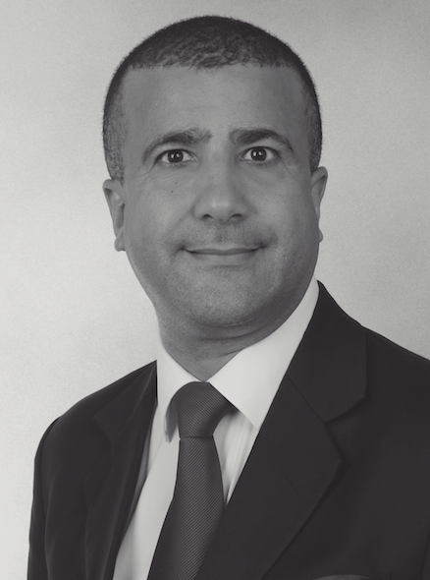
Dr Abbes Sebihi
Dr Abbes Sebihi is a German senior education and training specilist, expert in the field of technical and vocational education and training (TVET), technology-mediated learning and pedagogies, international higher education, and institutional and capacity development. After completing IT master degree studies in France, he pursued academic research programmes in the field of education, e-learning and pedagogies both in Canada and Germany. He obtained his doctoral degree with highest honors at the prestigious Georg-August-University of Göttingen, where he also worked as a lecturer.

